**Comprehensive Report on Deep Learning**

SUBMITTED BY

NAME=DEVANSH PATEL

ROLL.NO=20230034

**Table of Contents**

1. **Introduction**
2. **Historical Background**
3. **Key Concepts in Deep Learning**
4. **Convolutional Neural Networks (CNNs)**
5. **Recurrent Neural Networks (RNNs)**
6. **Transformers**
7. **PyTorch**

**8.Conclusion**

**Deep Learning**

Deep learning is a subset of [machine learning](https://www.ibm.com/topics/machine-learning) that uses multilayered [neural networks](https://www.ibm.com/topics/neural-networks), called deep neural networks, to simulate the complex decision-making power of the human brain. Some form of deep learning powers most of the [artificial intelligence (AI)](https://www.ibm.com/topics/artificial-intelligence) applications in our lives today.

The chief difference between deep learning and machine learning is the structure of the underlying neural network architecture. “Nondeep,” [traditional machine learning](https://www.ibm.com/blog/machine-learning-types/) models use simple neural networks with one or two computational layers. Deep learning models use three or more layers—but typically hundreds or thousands of layers—to train the models.

While supervised learning models require structured, labeled input data to make accurate outputs, deep learning models can use unsupervised learning. With unsupervised learning, deep learning models can extract the characteristics, features and relationships they need to make accurate outputs from raw, unstructured data. Additionally, these models can even evaluate and refine their outputs for increased precision.

Deep learning is an aspect of data science that drives many applications and services that improve [automation](https://www.ibm.com/consulting/automation), performing analytical and physical tasks without human intervention. This enables many everyday products and services—such as digital assistants, voice-enabled TV remotes, credit card fraud detection, self-driving cars and generative AI.

Historical Background of Deep Learning

Early Beginnings (1940s - 1980s)

* 1943: Warren McCulloch and Walter Pitts published a paper on a computational model for neural networks based on algorithms called threshold logic. This work laid the foundation for neural network research.
* 1950s - 1960s: Researchers like Frank Rosenblatt developed the Perceptron, a type of artificial neural network that could learn simple patterns. However, the limitations of the Perceptron, especially its inability to solve non-linear problems, were highlighted by Marvin Minsky and Seymour Papert in 1969.

The Winter of AI (1970s - 1980s)

* During this period, neural network research saw reduced interest and funding. This period is often referred to as the "AI Winter" due to the slow progress and skepticism in the field.

Backpropagation and Revival (1980s - 1990s)

* 1986: The backpropagation algorithm, rediscovered and popularized by Rumelhart, Hinton, and Williams, provided a method to train multi-layer neural networks effectively. This breakthrough revitalized interest in neural networks.
* Throughout the 1990s, neural networks were applied to various tasks, but their use was limited due to computational constraints and lack of large datasets.

The Rise of Deep Learning (2000s - 2010s)

* 2006: Geoffrey Hinton and his team demonstrated that deep neural networks could be pre-trained layer-by-layer using unsupervised learning, making it easier to train deeper networks. This work reignited interest in deep learning.
* 2012: A significant milestone was the victory of AlexNet, a deep convolutional neural network, in the ImageNet competition. This event marked the beginning of the deep learning revolution, showing the power of deep architectures in image recognition tasks.

Modern Era (2010s - Present)

* Deep learning has rapidly advanced, powered by the availability of large datasets, advances in computational power (especially GPUs), and improvements in algorithms and architectures.
* Key innovations include:
  + Convolutional Neural Networks (CNNs): Excelling in image and video processing.
  + Recurrent Neural Networks (RNNs) and Long Short-Term Memory Networks (LSTMs): Excelling in sequence and time-series data.
  + Generative Adversarial Networks (GANs): Capable of generating new data.
  + Transformers: Revolutionizing natural language processing tasks.

Key Concepts of Deep Learning

Deep learning is a subset of machine learning, characterized by the use of neural networks with many layers (hence "deep" networks). Here are some of the key concepts essential to understanding deep learning:

1. Neural Networks

* Artificial Neurons: The basic unit of a neural network, modeled after biological neurons. An artificial neuron receives input, processes it through a weighted sum, applies an activation function, and produces an output.
* Layers: Neural networks are composed of an input layer, one or more hidden layers, and an output layer. Each layer consists of multiple neurons.

2. Activation Functions

* Activation functions introduce non-linearity into the network, allowing it to learn complex patterns. Common activation functions include:
  + Sigmoid: σ(x)=11+e−x\sigma(x) = \frac{1}{1 + e^{-x}}σ(x)=1+e−x1​
  + Tanh: tanh(x)=ex−e−xex+e−x\text{tanh}(x) = \frac{e^x - e^{-x}}{e^x + e^{-x}}tanh(x)=ex+e−xex−e−x​
  + ReLU (Rectified Linear Unit): ReLU(x)=max⁡(0,x)\text{ReLU}(x) = \max(0, x)ReLU(x)=max(0,x)
  + Leaky ReLU: A variant of ReLU that allows a small gradient when the unit is not active.

3. Training Deep Networks

* Forward Propagation: The process of passing input data through the network to obtain the output.
* Loss Function: Measures the difference between the predicted output and the actual target. Common loss functions include Mean Squared Error (MSE) for regression and Cross-Entropy Loss for classification.
* Backpropagation: A method for training neural networks by calculating the gradient of the loss function with respect to each weight using the chain rule, and then updating the weights to minimize the loss.

4. Optimization Algorithms

* Algorithms used to update the network's weights to minimize the loss function. Common optimization algorithms include:
  + Stochastic Gradient Descent (SGD): Updates weights based on a small batch of data to speed up convergence.
  + Adam (Adaptive Moment Estimation): Combines the benefits of two other extensions of SGD, namely AdaGrad and RMSProp, by keeping an exponentially decaying average of past gradients and squared gradients.

5. Regularization Techniques

* Methods used to prevent overfitting, ensuring the model generalizes well to new data. Common techniques include:
  + Dropout: Randomly sets a fraction of input units to 0 at each update during training time, which helps prevent overfitting.
  + L1 and L2 Regularization: Adds a penalty term to the loss function based on the size of the weights.

6. Convolutional Neural Networks (CNNs)

* Specialized neural networks for processing data with a grid-like topology, such as images. Key components include:
  + Convolutional Layers: Apply convolution operations to input data, using filters/kernels to detect features.
  + Pooling Layers: Reduce the spatial dimensions of the data, typically using max pooling or average pooling, to make the network more computationally efficient and to control overfitting.

7. Recurrent Neural Networks (RNNs)

* Neural networks designed for sequential data, where connections between nodes form a directed graph along a temporal sequence. Variants include:
  + Long Short-Term Memory (LSTM): Designed to capture long-term dependencies and mitigate the vanishing gradient problem.
  + Gated Recurrent Units (GRUs): A simpler alternative to LSTMs that also addresses the vanishing gradient problem.

8. Transformers

* A type of model that relies on self-attention mechanisms to process sequences of data. Transformers have revolutionized natural language processing (NLP) with models like BERT and GPT.

9. Transfer Learning

* The practice of taking a pre-trained model (trained on a large dataset) and fine-tuning it on a smaller, specific dataset. This technique leverages the knowledge learned from the large dataset to improve performance on the specific task.

10. Generative Models

* Models that can generate new data samples from the learned distribution of the training data. Examples include:
  + Generative Adversarial Networks (GANs): Consist of a generator and a discriminator network, where the generator creates fake data samples and the discriminator tries to distinguish them from real samples.
  + Variational Autoencoders (VAEs): Learn to encode data into a latent space and decode it back to reconstruct the original data.

**Convolutional Neural Network**

A [Convolutional Neural Network](https://www.geeksforgeeks.org/neural-networks-a-beginners-guide/)(CNN) is a type of [deep learning algorithm](https://www.geeksforgeeks.org/deep-learning-introduction-to-long-short-term-memory/) that is particularly well-suited for image recognition and processing tasks. It is made up of multiple layers, including convolutional layers, [pooling layers](https://www.geeksforgeeks.org/cnn-introduction-to-pooling-layer/), and fully connected layers. The architecture of CNNs is inspired by the visual processing in the human brain, and they are well-suited for capturing hierarchical patterns and spatial dependencies within images.

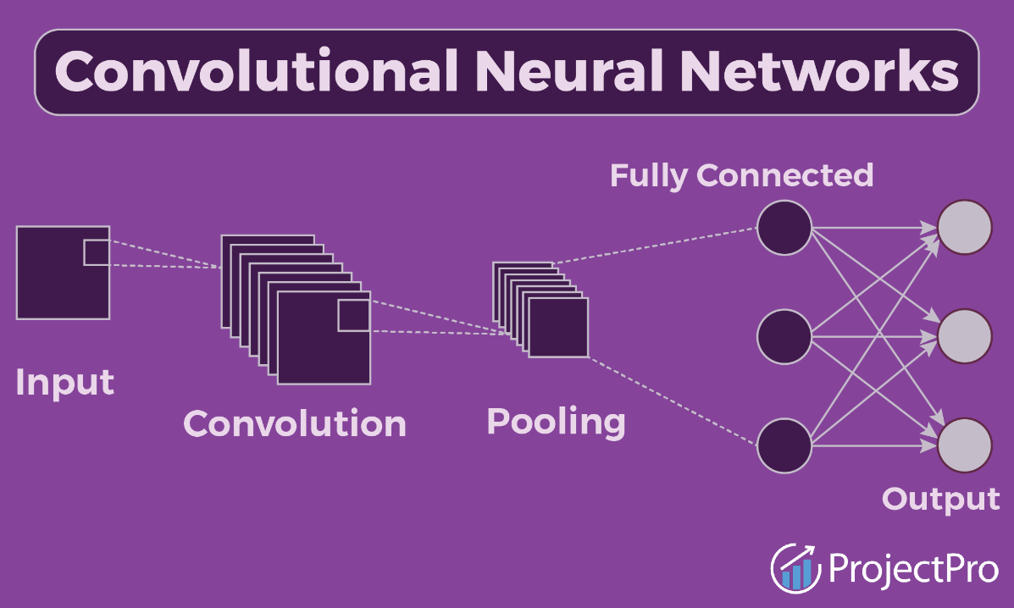

CNNs are trained using a large dataset of labeled images, where the network learns to recognize patterns and features that are associated with specific objects or classes. Proven to be highly effective in [image-related tasks](https://www.geeksforgeeks.org/image-classifier-using-cnn/), achieving state-of-the-art performance in various computer vision applications. Their ability to automatically learn hierarchical representations of features makes them well-suited for tasks where the spatial relationships and patterns in the data are crucial for accurate predictions. CNNs are widely used in areas such as image classification, object detection, facial recognition, and medical image analysis.

The convolutional layers are the key component of a CNN, where filters are applied to the input image to extract features such as edges, textures, and shapes.

The output of the convolutional layers is then passed through pooling layers, which are used to down-sample the [feature maps](https://www.geeksforgeeks.org/feature-mapping/), reducing the spatial dimensions while retaining the most important information. The output of the pooling layers is then passed through one or more fully connected layers, which are used to make a prediction or classify the image.

Key Concepts of Convolutional Neural Networks (CNNs)

Convolutional Neural Networks (CNNs) are a class of deep neural networks specifically designed to process and analyze grid-like data structures such as images. Here are the key concepts that form the foundation of CNNs:

1. Convolutional Layers

* Convolution Operation: The core building block of CNNs, where a filter (or kernel) slides over the input data to produce a feature map. Each filter detects a specific feature such as edges, textures, or colors.
  + Stride: The number of pixels by which the filter moves over the input matrix. A stride of 1 means the filter moves one pixel at a time.
  + Padding: Adding zeros around the input matrix borders to control the spatial dimensions of the output. Common types include 'valid' (no padding) and 'same' (padding so output size matches input size).
* Receptive Field: The region of the input image that a particular CNN layer's neuron is "looking at."

2. Activation Functions

* ReLU (Rectified Linear Unit): The most commonly used activation function in CNNs, applied after each convolution operation to introduce non-linearity.
  + Formula:ReLU(x)=max(0,x)
* Leaky ReLU: A variant of ReLU that allows a small, non-zero gradient when the unit is inactive.
  + Formula:Leaky ReLU(x)=max(0.01x,x)

3. Pooling Layers

* Max Pooling: Reduces the spatial dimensions (width and height) of the input by taking the maximum value over a defined subregion.
  + Example: A 2x2 max pooling operation reduces a 4x4 feature map to a 2x2 feature map.
* Average Pooling: Reduces the spatial dimensions by taking the average value over a defined subregion.
* Pooling helps in making the representation smaller and more manageable, reducing the number of parameters and computations in the network, and helps control overfitting.

4. Fully Connected Layers

* After several convolutional and pooling layers, the high-level reasoning in the neural network is done via fully connected (dense) layers. These layers connect every neuron in one layer to every neuron in the next layer.
* Typically used at the end of the network to output a classification result.

5. Normalization Techniques

* Batch Normalization: Normalizes the output of a previous activation layer by subtracting the batch mean and dividing by the batch standard deviation. This helps in speeding up training and providing some regularization.
* Formula:
  + 
* Layer Normalization: Normalizes across the features instead of the batch dimension.

6. Dropout

* A regularization technique where randomly selected neurons are ignored during training. This helps prevent overfitting by ensuring that the network does not rely too heavily on any one neuron.
* Typically applied to fully connected layers.

7. Transfer Learning

* Using a pre-trained CNN (trained on a large dataset like ImageNet) as a starting point. The pre-trained model's weights are fine-tuned on a smaller dataset specific to the new task.
* Common practice involves freezing the initial layers of the pre-trained network and training only the top layers.

8. Common CNN Architectures

* LeNet-5: One of the earliest CNN architectures, designed for handwritten digit recognition (MNIST dataset).
* AlexNet: Won the ImageNet competition in 2012, demonstrating the power of deep CNNs. It consists of five convolutional layers followed by three fully connected layers.
* VGGNet: Known for its simplicity and use of very small (3x3) convolution filters. VGG16 and VGG19 are popular variants.
* ResNet (Residual Networks): Introduced the concept of residual learning with skip connections, allowing the training of much deeper networks.
* Inception (GoogLeNet): Utilizes inception modules that apply multiple convolutions and pooling operations in parallel.

## **Applications of CNN**

* **Image classification:** CNNs are the state-of-the-art models for image classification. They can be used to classify images into different categories, such as cats and dogs, cars and trucks, and flowers and animals.
* **Object detection:** CNNs can be used to detect objects in images, such as people, cars, and buildings. They can also be used to localize objects in images, which means that they can identify the location of an object in an image.
* **Image segmentation:** CNNs can be used to segment images, which means that they can identify and label different objects in an image. This is useful for applications such as medical imaging and robotics.
* **Video analysis:** CNNs can be used to analyze videos, such as tracking objects in a video or detecting events in a video. This is useful for applications such as video surveillance and traffic monitoring.

**Recurrent Neural Network**

Recurrent Neural Network(RNN) is a type of [Neural Network](https://www.geeksforgeeks.org/tag/neural-network) where the output from the previous step is fed as input to the current step. In traditional neural networks, all the inputs and outputs are independent of each other. Still, in cases when it is required to predict the next word of a sentence, the previous words are required and hence there is a need to remember the previous words. Thus RNN came into existence, which solved this issue with the help of a Hidden Layer. The main and most important feature of RNN is its Hidden state, which remembers some information about a sequence. The state is also referred to as *Memory State*since it remembers the previous input to the network. It uses the same parameters for each input as it performs the same task on all the inputs or hidden layers to produce the output. This reduces the complexity of parameters, unlike other neural networks.

### Key Concepts of Recurrent Neural Networks (RNNs)

Recurrent Neural Networks (RNNs) are a class of neural networks designed for sequential data. They are widely used for tasks where the order of the input data is crucial, such as time series prediction, natural language processing, and speech recognition. Here are the key concepts of RNNs:

#### 1. ****Sequential Data Processing****

* **Recurrent Neurons**: Unlike traditional neural networks, RNNs have neurons with connections that form directed cycles. This structure allows the network to maintain a state or memory of previous inputs, making it well-suited for sequential data.
* **Hidden State**: The hidden state is a dynamic representation of the previous inputs, capturing the temporal dependencies in the data.

#### 2. ****Architecture****

* **Input Layer**: Receives the input sequence.
* **Hidden Layer**: Processes each element of the sequence while maintaining a hidden state that is updated at each time step.
* **Output Layer**: Produces the output sequence or a single output after processing the entire input sequence.

#### 3. ****Mathematical Formulation****

* The hidden state at time ttt (hth_tht​) is calculated as a function of the input at time ttt (xtx_txt​) and the hidden state at the previous time step (ht−1h_{t-1}ht−1​).



* + σ is the activation function, typically tanh or ReLU.
* The output (yt) is computed from the hidden state.

Formula:

* + ϕ is usually a softmax or sigmoid function for classification tasks.

4. **Training RNNs**

* **Backpropagation Through Time (BPTT)**: A variant of the backpropagation algorithm used to train RNNs. It involves unrolling the network through time and computing gradients for each time step.
* **Vanishing and Exploding Gradients**: A common problem in training RNNs where gradients can become very small (vanishing) or very large (exploding), making it difficult to train long sequences.

#### 5. ****Variants of RNNs****

* **Long Short-Term Memory (LSTM)**: Designed to mitigate the vanishing gradient problem by introducing a more complex cell structure with gates (input, forget, and output gates) that control the flow of information.
  + **LSTM Cell**: Consists of a cell state that carries long-term information, and gates that update the cell state.
* **Gated Recurrent Unit (GRU)**: A simpler alternative to LSTMs that also addresses the vanishing gradient problem. It combines the cell state and hidden state and uses update and reset gates.
* **Bidirectional RNNs**: Process the input sequence in both forward and backward directions, capturing context from both past and future states.
* **Attention Mechanism**: Allows the model to focus on specific parts of the input sequence when making predictions, improving performance on tasks like machine translation.

**Applications of RNNs**

* **Natural Language Processing (NLP)**: Tasks like language modeling, text generation, machine translation, and sentiment analysis.
* **Speech Recognition**: Converting spoken language into text.
* **Time Series Prediction**: Forecasting future values based on historical data.
* **Video Analysis**: Understanding and predicting sequences of video frames.
* **Music Generation**: Creating new music sequences based on learned patterns.

**Transformer**

Transformers have revolutionized the field of deep learning, particularly in natural language processing (NLP). They address the limitations of traditional RNNs and CNNs in handling sequential data, enabling parallelization and capturing long-range dependencies effectively.

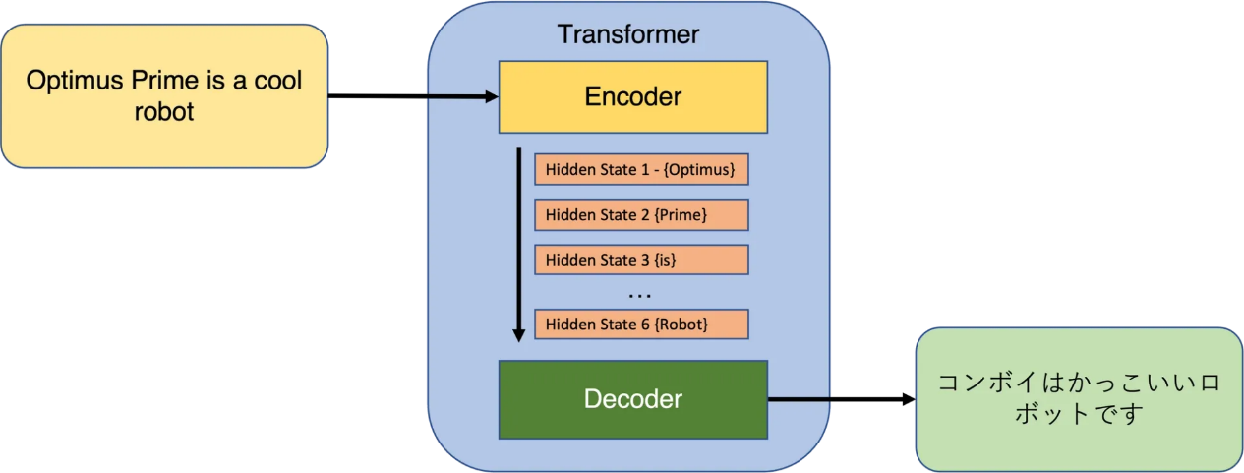

Here are the key concepts of Transformers:

#### 1. ****Architecture****

* **Self-Attention Mechanism**: The core component of the Transformer. It allows the model to weigh the importance of different words in a sentence, capturing dependencies regardless of their distance from each other.
* **Encoder-Decoder Structure**:
  + **Encoder**: Composed of a stack of identical layers, each containing:
    - **Multi-Head Self-Attention**: Computes attention multiple times with different weight matrices and concatenates the results.
    - **Feed-Forward Neural Network**: Applies a fully connected feed-forward network to each position independently and identically.
    - **Add & Norm**: Layer normalization and residual connections around the sub-layers.
  + **Decoder**: Similar to the encoder but with an additional multi-head attention mechanism to attend to the encoder's output.

#### 2. ****Self-Attention Mechanism****

* **Scaled Dot-Product Attention**: Computes attention scores for each word pair.



* + Q (Query), K (Key), and V (Value) are derived from the input embeddings.
  + dk​ is the dimension of the key vectors.
* **Multi-Head Attention**: Allows the model to focus on different parts of the input simultaneously.
  + It applies multiple attention heads in parallel and concatenates their outputs.

#### 

#### 3. ****Positional Encoding****

* Since transformers do not have a built-in notion of the order of elements in a sequence (unlike RNNs), positional encodings are added to the input embeddings to provide information about the position of each word in the sequence.
  + Common approach: Sine and cosine functions of different frequencies.
  + Formula:

#### 

#### 4. ****Training and Optimization****

* **Loss Function**: Typically, cross-entropy loss for tasks like language modeling and translation.
* **Optimization**: Commonly optimized using Adam optimizer with specific learning rate schedules, such as the one proposed in the original Transformer paper (Vaswani et al., 2017).

#### 5. ****Applications****

* **Natural Language Processing (NLP)**:
  + **Language Translation**: e.g., Google's Transformer-based translation system.
  + **Text Summarization**: Generating concise summaries of long texts.
  + **Question Answering**: e.g., BERT and GPT models.
  + **Language Generation**: e.g., GPT (Generative Pre-trained Transformer).
* **Vision Transformers (ViTs)**: Applying Transformer architecture to image processing tasks by treating image patches as sequences.
* **Speech Processing**: Tasks like speech recognition and synthesis.

#### 6. ****Popular Transformer Models****

* **BERT (Bidirectional Encoder Representations from Transformers)**: Pre-trained on large text corpora using masked language modeling and next sentence prediction, fine-tuned for specific tasks.
* **GPT (Generative Pre-trained Transformer)**: Focuses on language generation, trained in an unsupervised manner and fine-tuned for specific tasks.
* **T5 (Text-to-Text Transfer Transformer)**: Converts all NLP tasks into a text-to-text format, leveraging a unified framework.
* **Vision Transformer (ViT)**: Applies Transformer architecture to image recognition tasks by dividing images into patches and processing them as sequences.

**PyTorch**

PyTorch is an open-source machine learning library developed primarily by Facebook's AI Research lab (FAIR). It is widely used for deep learning applications and provides a flexible framework for building and training neural networks.

**Key Features:**

1. **Tensor Computation**:
   * At its core, PyTorch provides powerful multi-dimensional array operations, similar to NumPy arrays but optimized for GPU acceleration.
   * Tensors in PyTorch can be used to represent and manipulate data at various stages of a machine learning pipeline, from input data to model predictions.
2. **Automatic Differentiation**:
   * One of PyTorch's standout features is its automatic differentiation capability through the autograd package.
   * This feature allows gradients to be computed automatically for tensors, facilitating efficient implementation of gradient-based optimization algorithms like backpropagation.
3. **Dynamic Computation Graphs**:
   * PyTorch uses a dynamic computational graph approach, where the graph is built on-the-fly during runtime.
   * This dynamic nature enables more flexible and intuitive model construction compared to static graph frameworks.
4. **Modular and Extensible**:
   * PyTorch offers a modular and extensible architecture, allowing developers to build complex neural network architectures with ease.
   * It provides a rich set of built-in modules and utilities for defining layers, activation functions, loss functions, and more.
5. **Support for GPU Acceleration**:
   * PyTorch seamlessly integrates with CUDA-capable GPUs to leverage their parallel processing capabilities.
   * This GPU acceleration significantly speeds up computations, making it ideal for training deep neural networks on large datasets.

**Conclusion:**

Deep learning represents a pivotal advancement in machine learning, marked by the evolution of artificial neural networks and the development of specialized architectures such as Convolutional Neural Networks (CNNs), Recurrent Neural Networks (RNNs), and Transformers. These innovations have significantly enhanced the ability to process and analyze complex data. PyTorch, with its robust tensor computation, automatic differentiation capabilities, and GPU acceleration support, has emerged as a leading framework for the efficient development and deployment of deep learning models.

**Link:**

CNN: <https://colab.research.google.com/drive/16uMlJdXhcwJ8UY_3Bt5RtvSLHhWHCdkw>

RNN: <https://colab.research.google.com/drive/1adj8SJvXtYvTp7SIa90hRSmBuOrn9mCX>

Transformer: <https://colab.research.google.com/drive/1bL-fhA5ZjC_LvDB4xHvZnFWNNAEmGo1v#scrollTo=cuex7TVljC2C>

GITHUB REPOSITORY: <https://github.com/DevanshPatel234/FMML_Project_and_Labs>